Pixel core company

**User Guide**

**Creating an item:**

Upon adding a new item in the system follow the following steps:  
Step 1: From the Inventory Application > Items > Master Items.

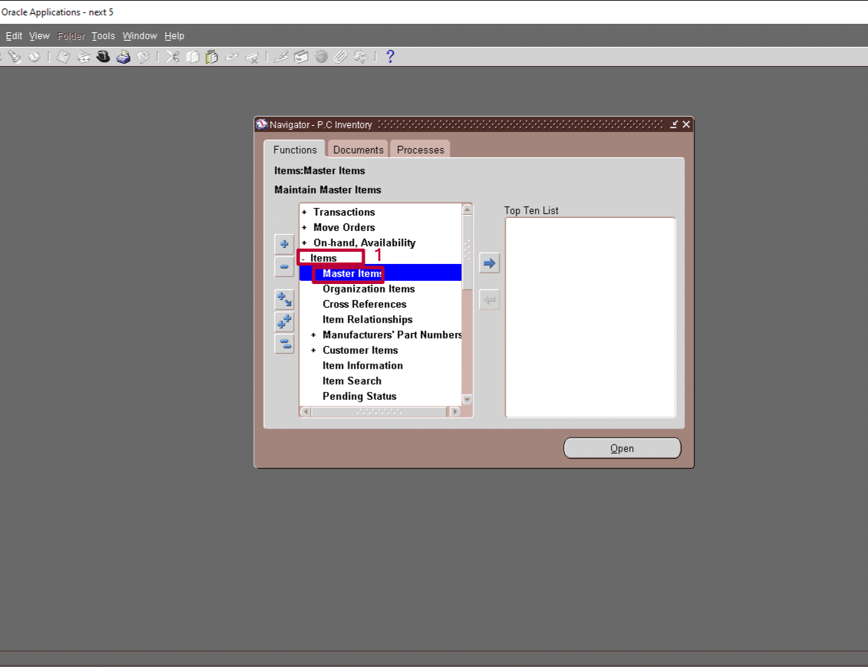

Step 2: Create a Unique Item Code for the Item and a description.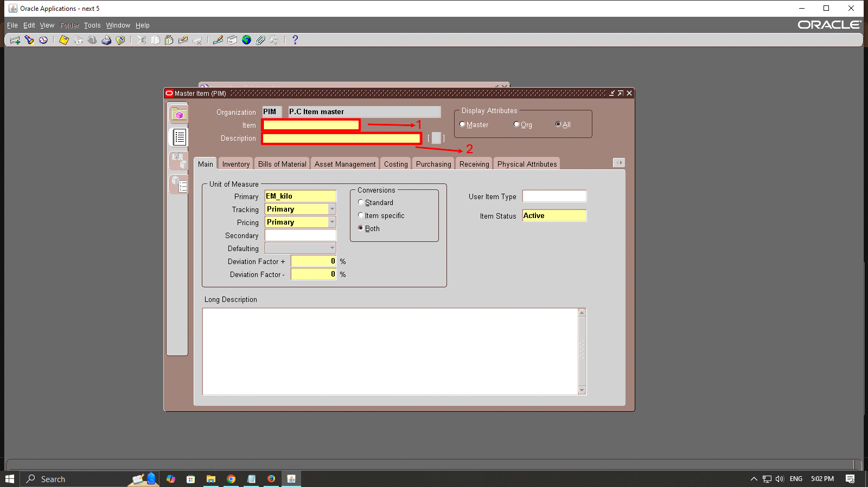

Step 3: Fill in the item attributes as required.

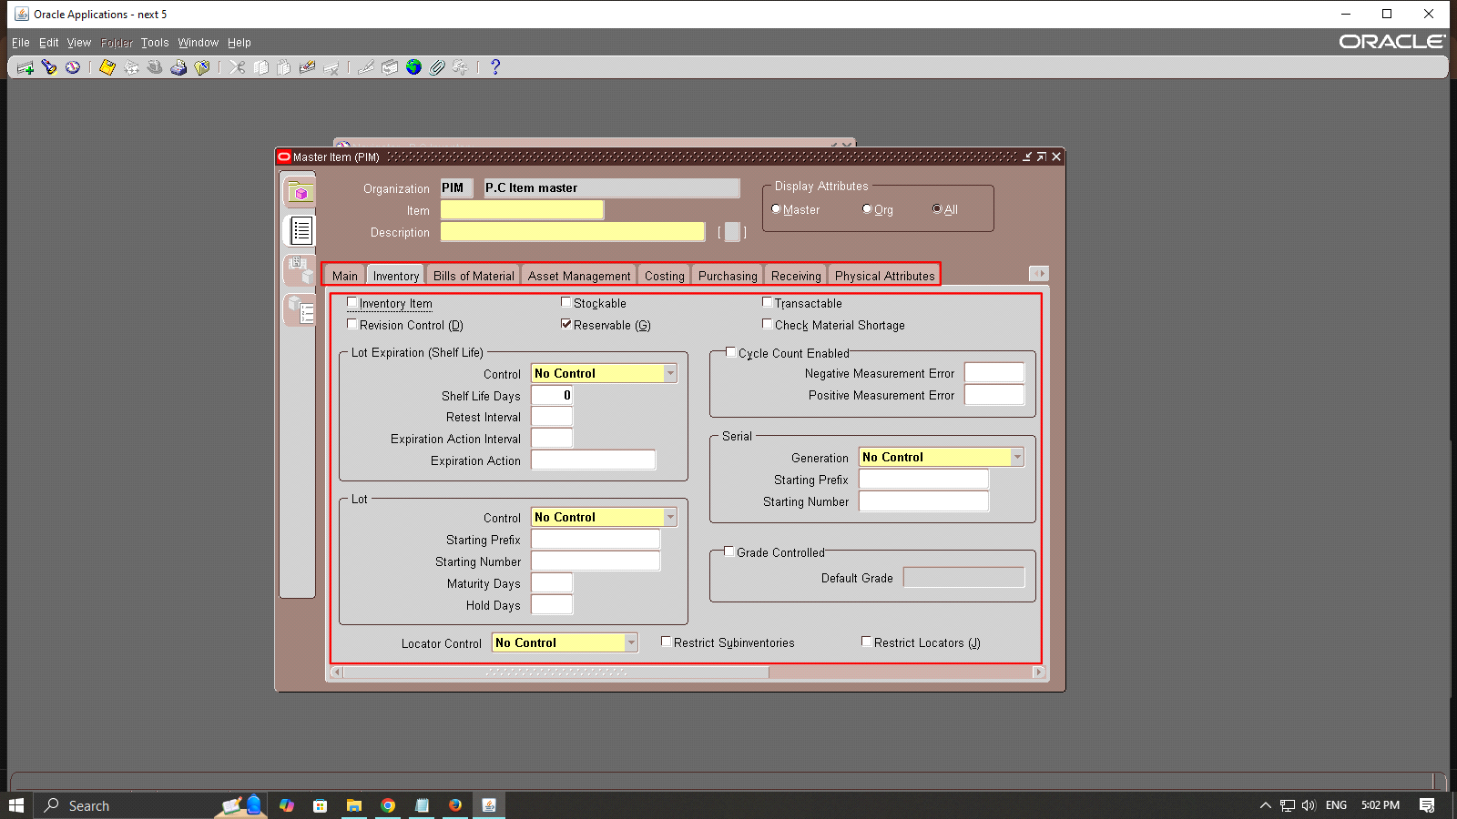

*Or you can copy from an already existing template or Item.

From “Tools” > “Copy From...”

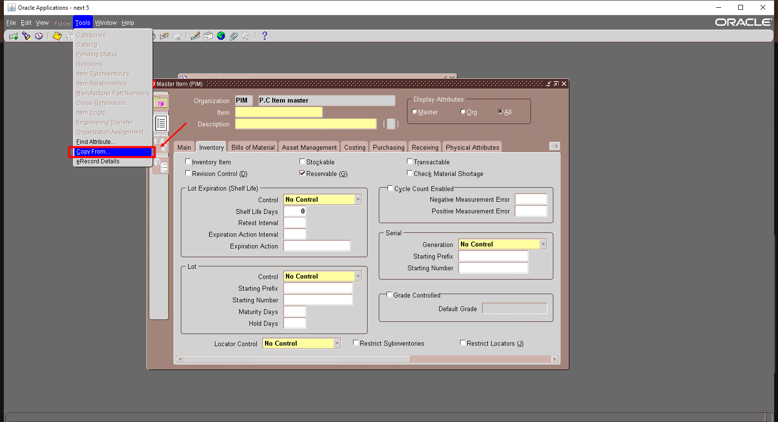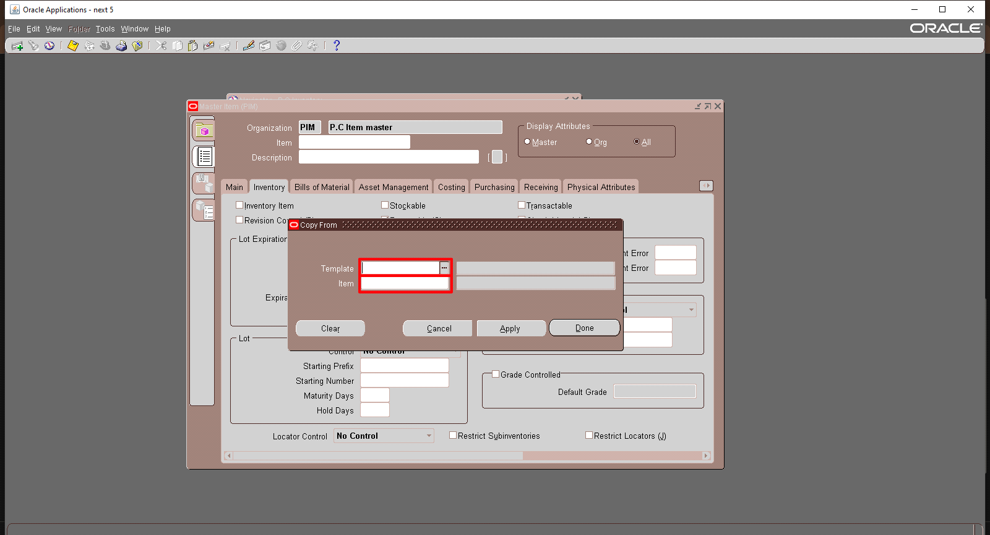

**Item attributes :**

**From main tab:**

⦁Unit of Measure (UOM): select a default UOM (P.C each)

⦁Item status: Ensure it is set to be (Active)

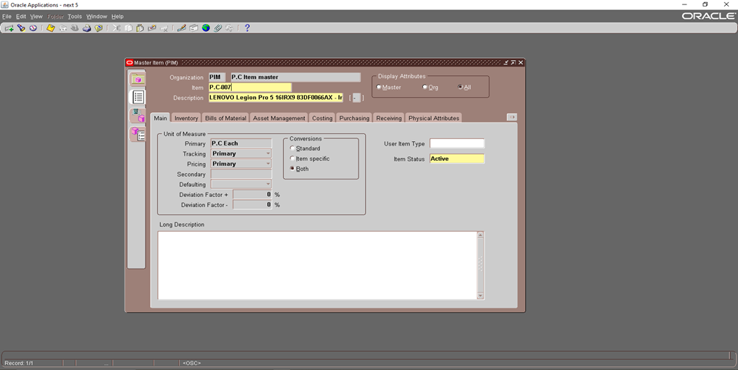

**From inventory tab:**

⦁Inventory Item: Used for Inventory tracking

⦁Stockable: Ensure the item can be stocked and maintained

⦁Reservable: Used for Item reservation

⦁Transactable: Ensure the item can be moved and transferred

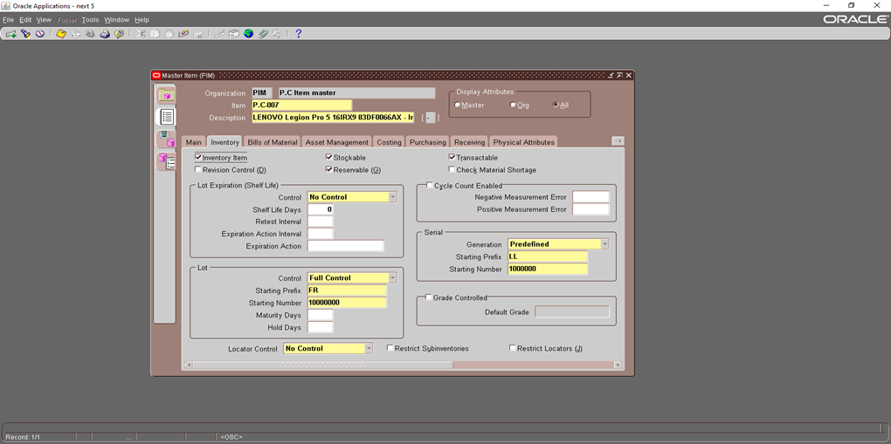

Lot control: Ensures batch traceability (Full control).

Serial number control: Ensures unique tracking of each unit (predefined) as Serial numbers must be defined in advance.

**From costing tab:**

⦁Costing enabled: Used to cost track the Item.

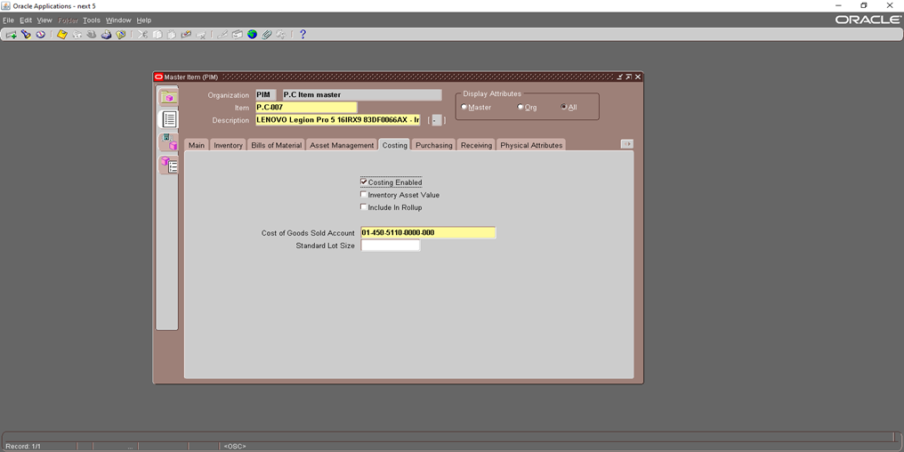

**From purchasing tab:**

⦁Purchased: Allow the item to be used in purchase order (PO).

⦁Purchasable: Allow the item to be selected in purchase order (PO).

⦁Allow Description Update: Allow users to edit in item description.

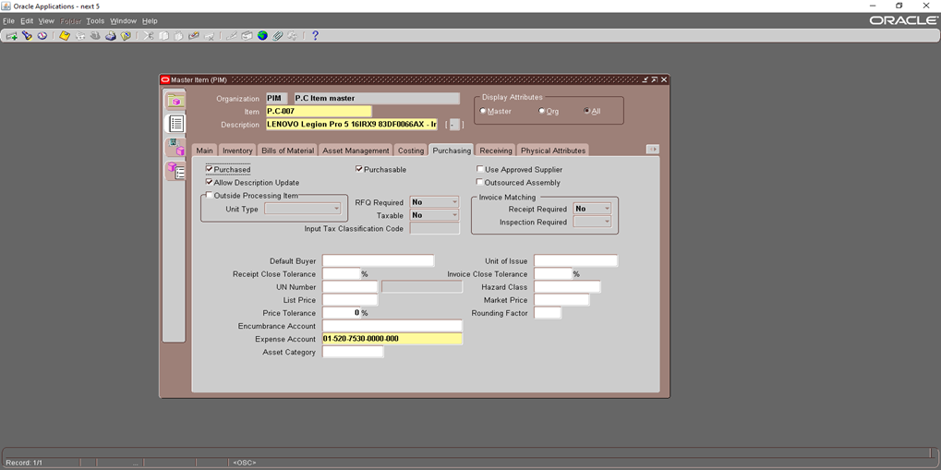

**From order management:**

⦁Customer Ordered: Ensure if the item can be in a sales order.

⦁Shippable: Ensure if the item is for shipping.

⦁Internal Ordered: Allows the item to be included in internal orders.

⦁Returnable: Allows the item to be returned

⦁RMA inspection required: ensures that returned items go through a quality check before they are accepted into inventory.

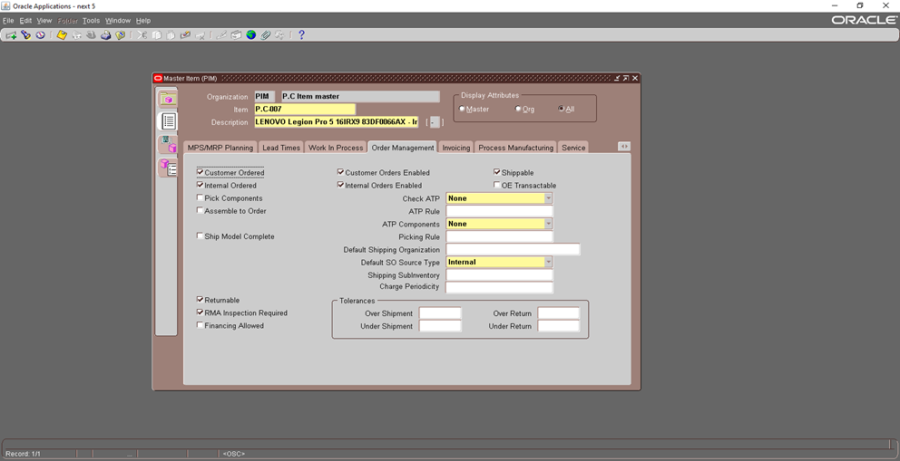

**From Invoicing tab:**

⦁Invoiceable: Allows the item to be in a customer invoice.

⦁Invoice enabled: Ensures the item can be processed in Oracle Receivables.

⦁Sales account revenue account where sales revenue is recorded (Inherited)

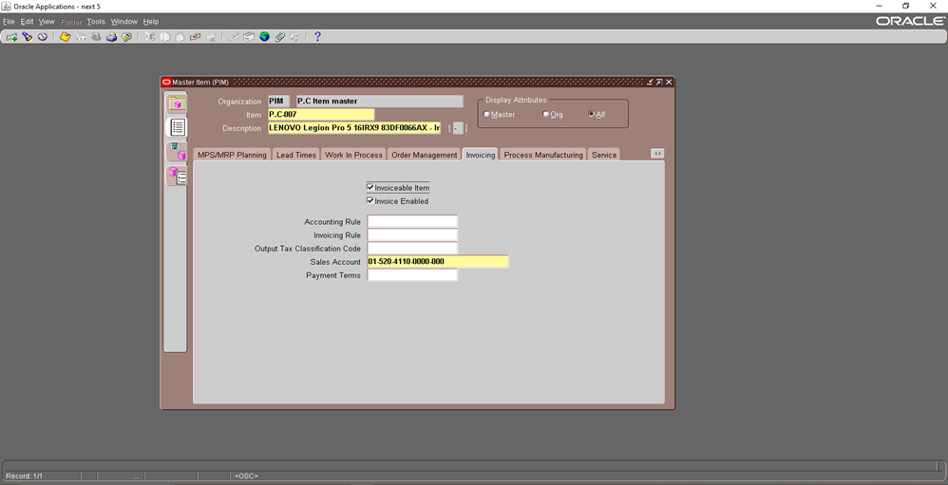

**Opening the Inventory Accounting Period:**

Upon opening an inventory accounting period, follow these steps:

Step 1: From the Inventory Application > Accounting close cycle > Inventory Accounting periods

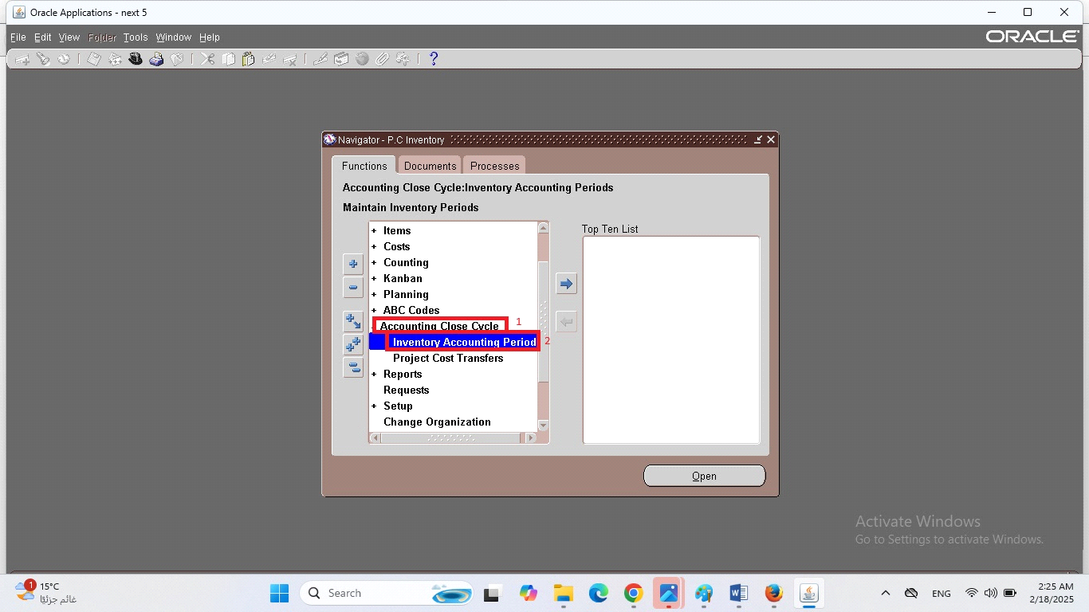

Step 2: Select the first Accounting Period

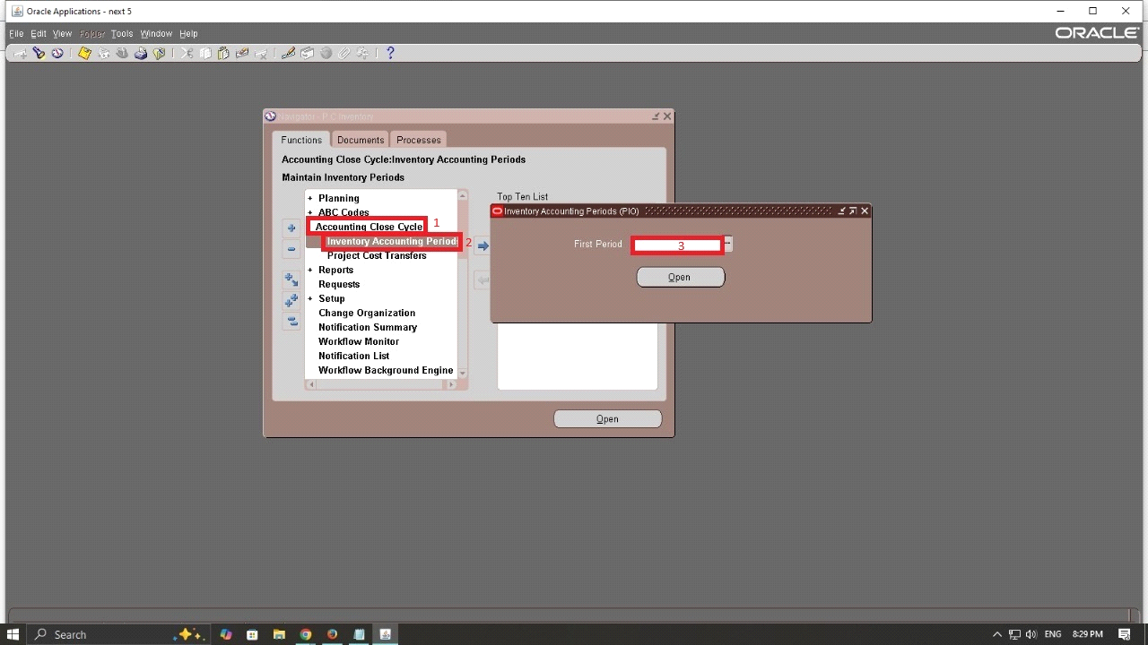

Step 3: Locate the period with the status ‘Future’ that correspond

to your first period then Click on the period row to highlight it

Step 4: Change the period status to open

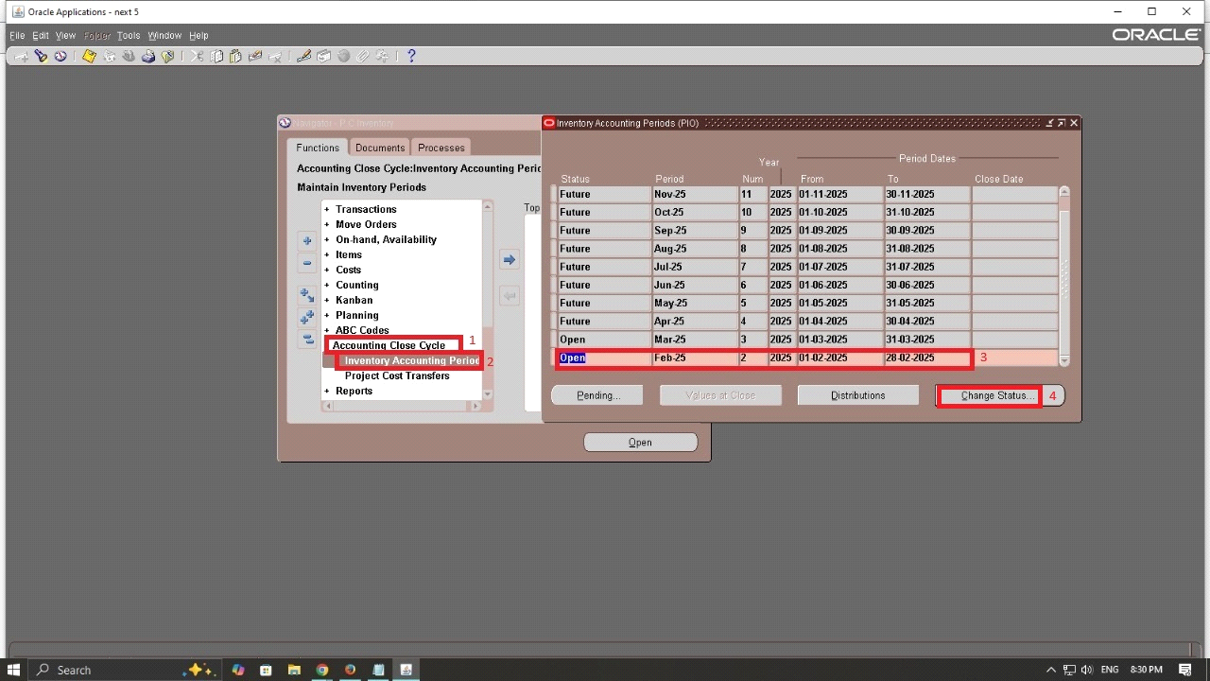

**Performing Miscellaneous Transactions:**

Upon performing miscellaneous transactions, follow these steps:

Step 1: From the Inventory Application > Transactions > Miscellaneous transactions

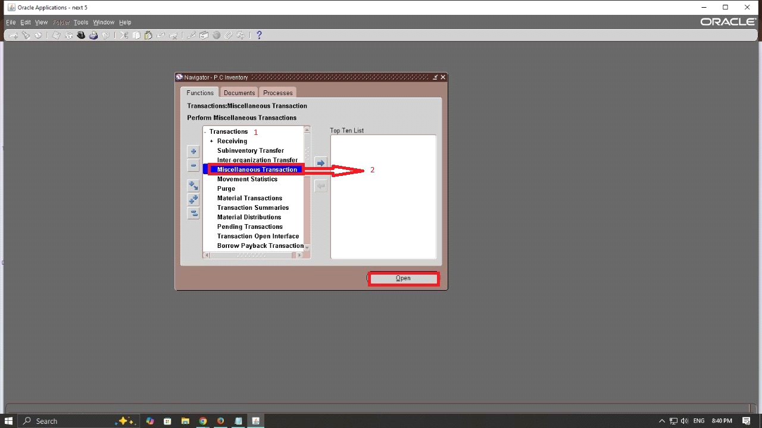

Step 2: Select the transaction type (Miscellaneous Receipt)

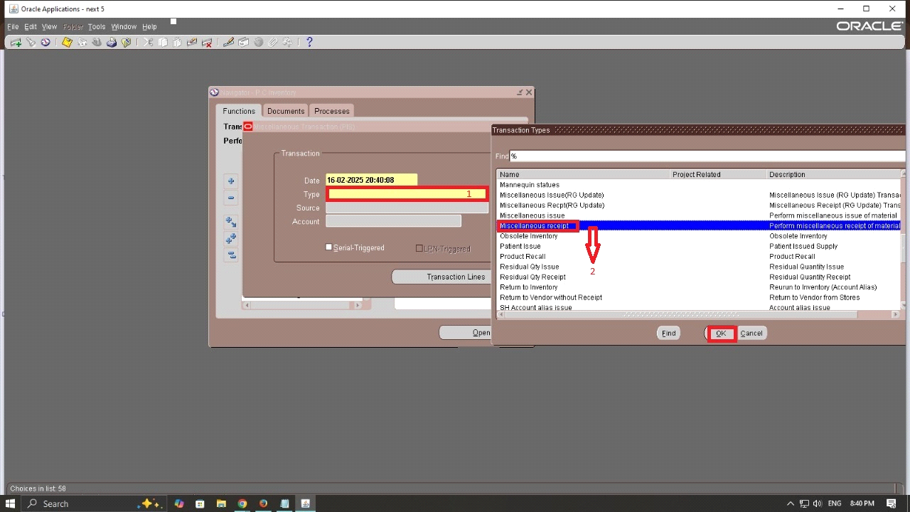

Step 3: Enter item details, click on the item field > Select the item > 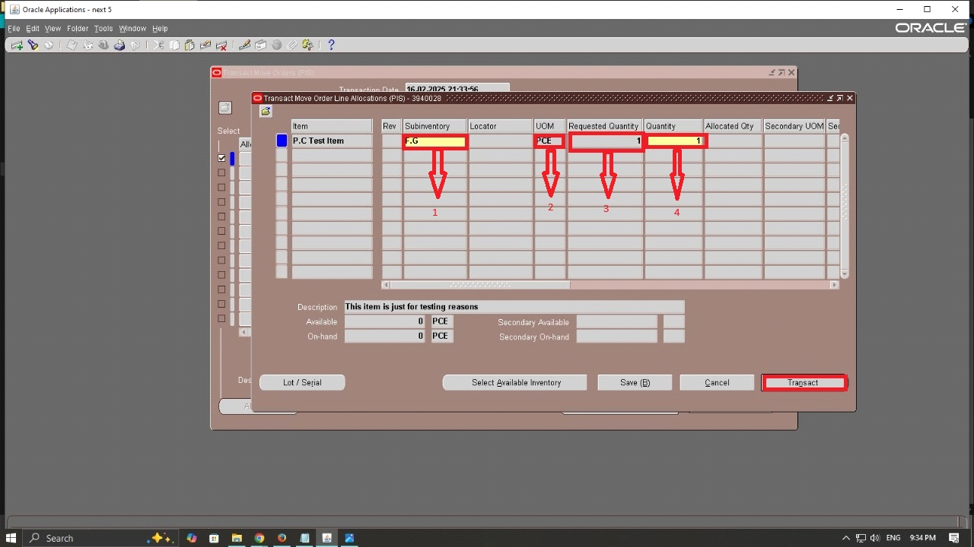

Select the sub inventory > Enter the quantity > Enter the Account

Step 4: Assign Lot numbers: In the lot Entry window > click Generate lot,Enter expiration date > Enter the quantity for each lot

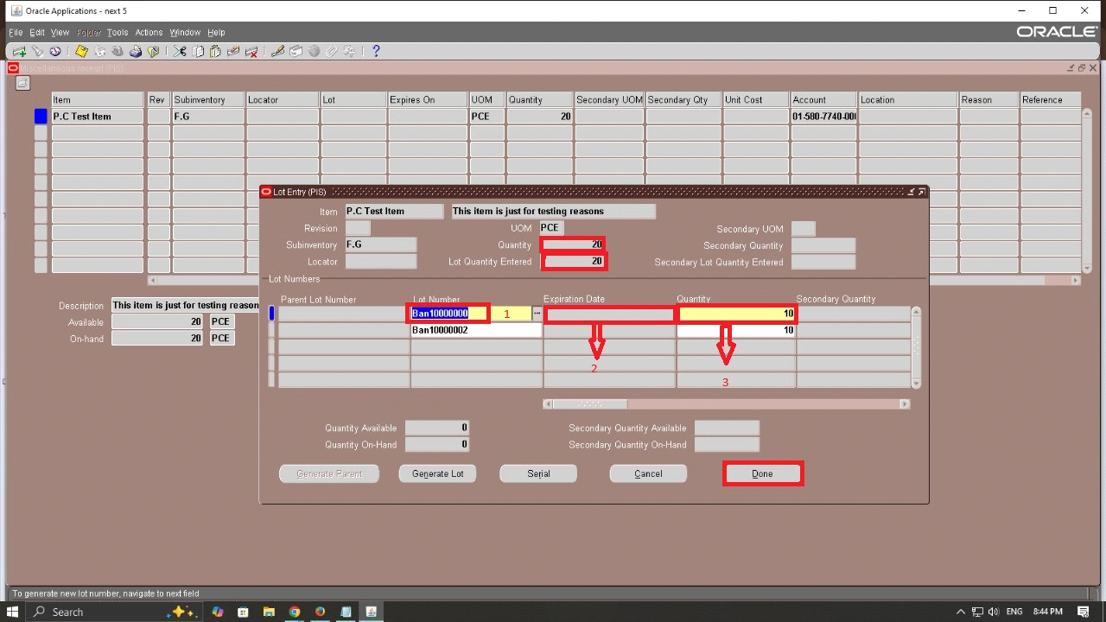

Step 5: Assign Serial number: choose serial number entry mode (Range) >Enter start serial number and end serial number > click done

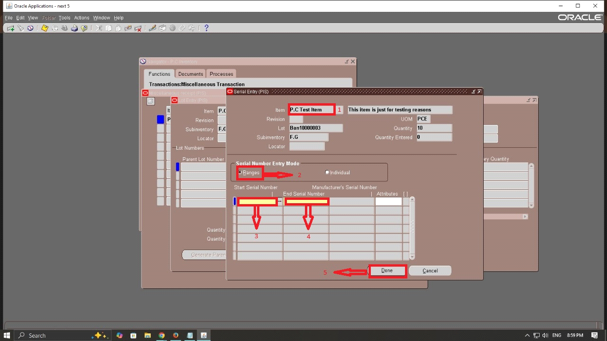

**Creating Move order:**

Step 1: From the Inventory Application > Transactions > Move orders > Move orders

Enter the following details:

* Move order Type: Select **Requisition**
* Move order Status: Select **Incomplete**
* Enter the date required **(16-2-2025)**

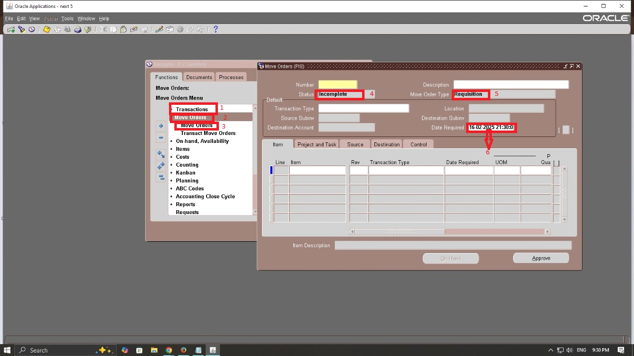

Step 2: Enter the item details:

Enter the item name **(P.C Test item)**

Select transaction type **(Move order issue)**

Set the primary quantity to the desired amount **(1)**

Enter the transaction date **(16-2-2025)**

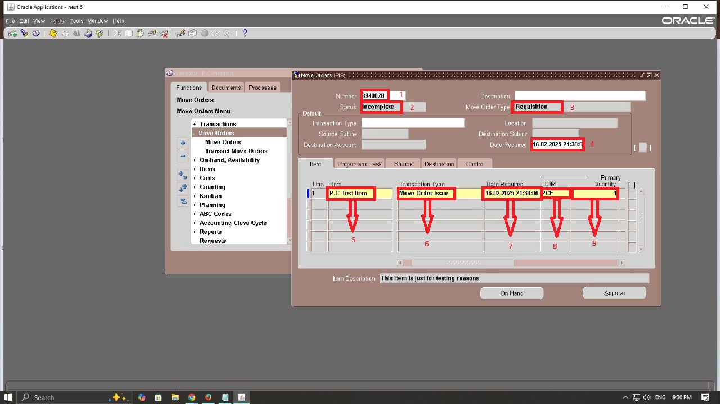

Step 3: Find the Move Order for Processing

Inventory > Transactions > Move Orders >Transact Move Orders

2. A Find Move Order Lines form will appear.

3. Enter the Move Order Number you created earlier and click Find.

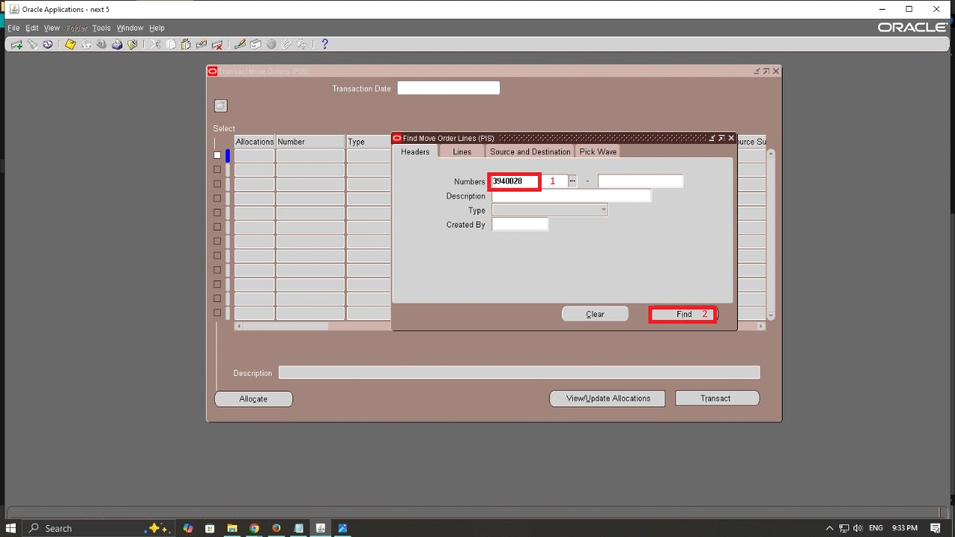

Step 4: Allocate Inventory

1. In the Transact Move Orders screen:

• Locate the move order by looking for the Move Order Number.

• Verify that the item appears with the Transaction Type as Move Order Issue.

• Click Allocate.

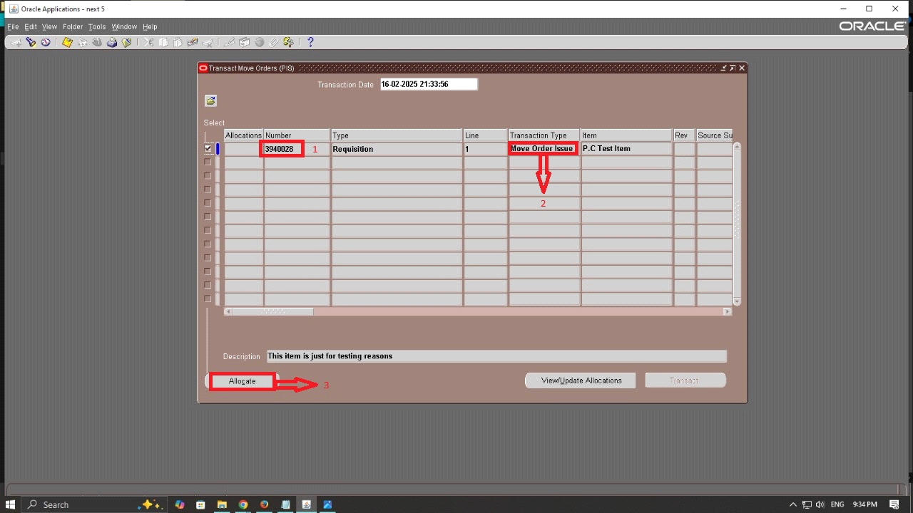

Step 5: Transact the Move Order

1. In the Transact Move Orders screen:

• Enter the details:

- Item: **P.C Test item**

- Sub inventory **(F.G)**

-UOM **(PCE)**

- Requested Quantity **(1)**

• Click Transact.

2. The move order is now successfully transacted, and inventory is moved accordingly.

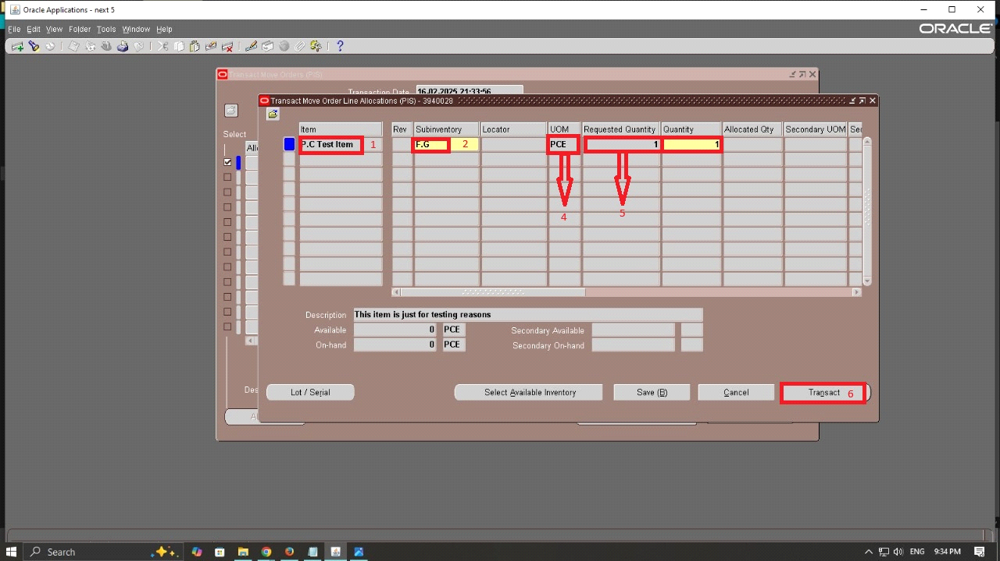

**Create subinventory transfer :**

Step 1: Inventory > Transactions > Subinventory transfer

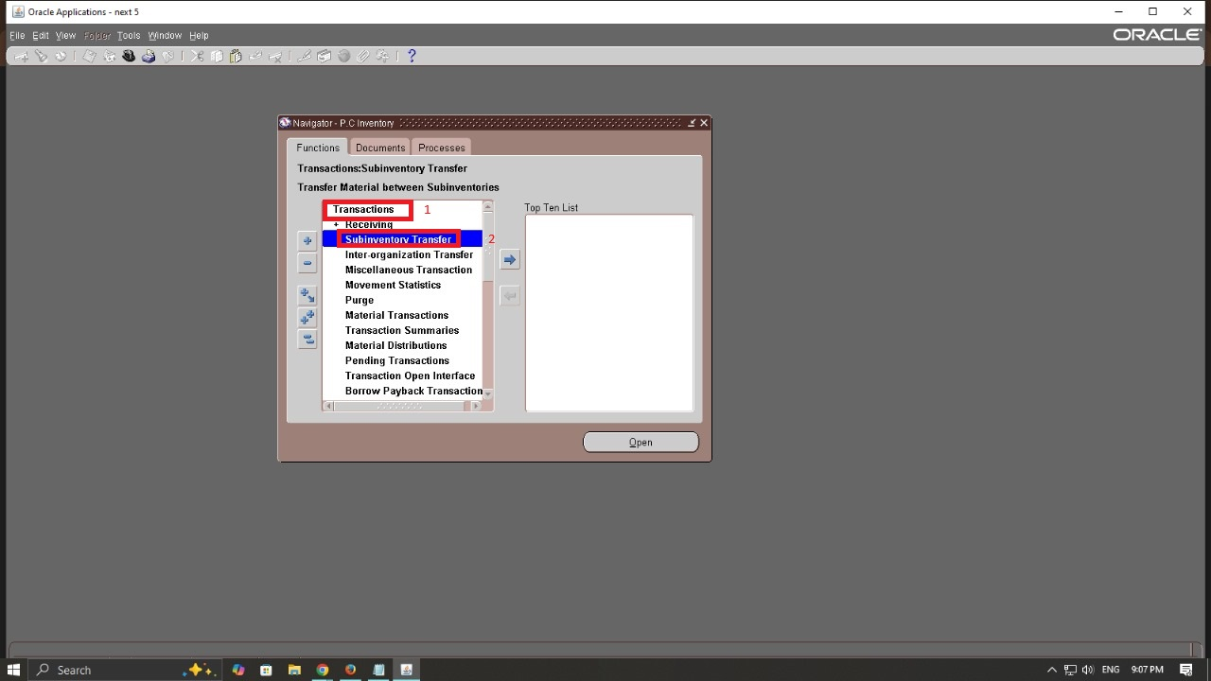

Step 2 : Select the Transfer Type

• Enter the Transaction Date.

• Click on the Type field.

• Select Subinventory Transfer from the list.

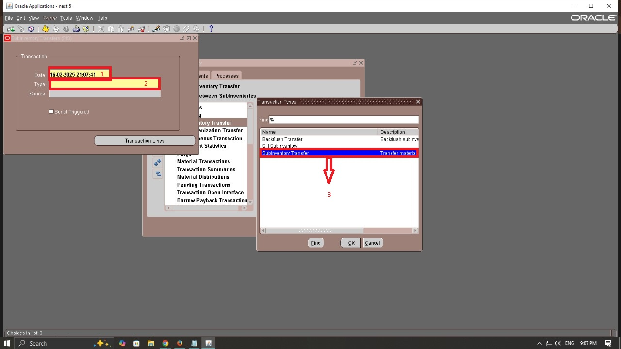

Step 3 :

• From Subinventory: Enter the source subinventory **(F.G).**

• To Subinventory: Enter the destination subinventory **(S.P).**

• Click Lot/Serial

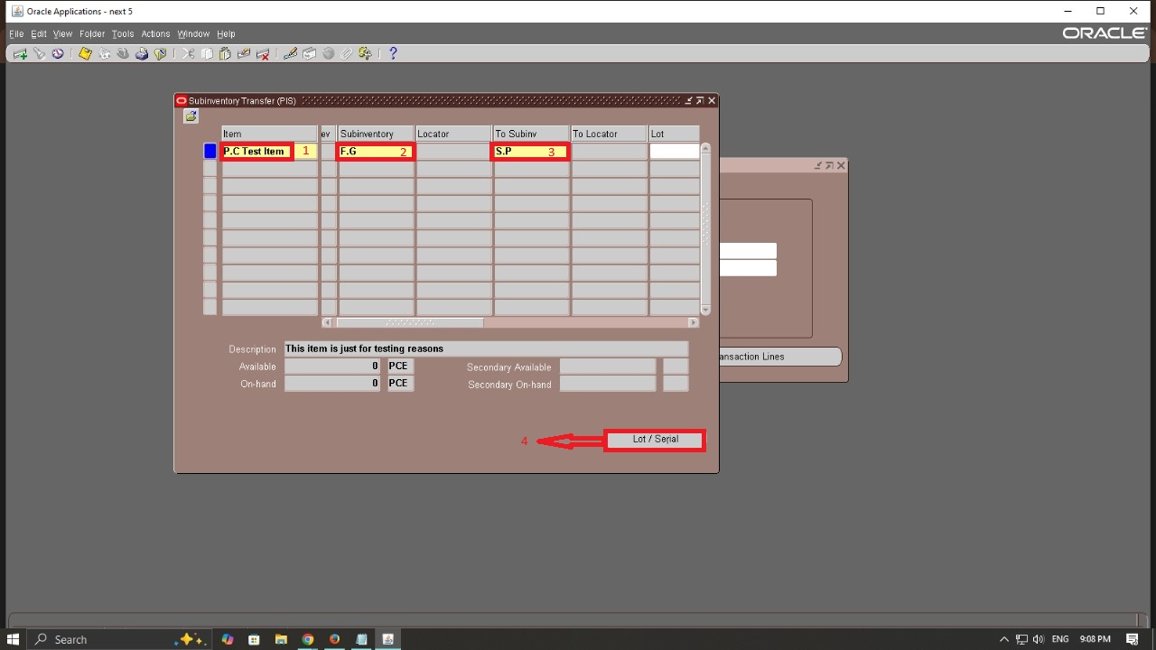

Step 4: Enter Transfer Details

1. In the Subinventory Transfer screen:

• Item: Select the item **( P.C Test Item)**

• UOM (Unit of Measure): **PCE**

• Quantity: Enter the number of units to transfer. **(10)**

• Click Lot/Serial

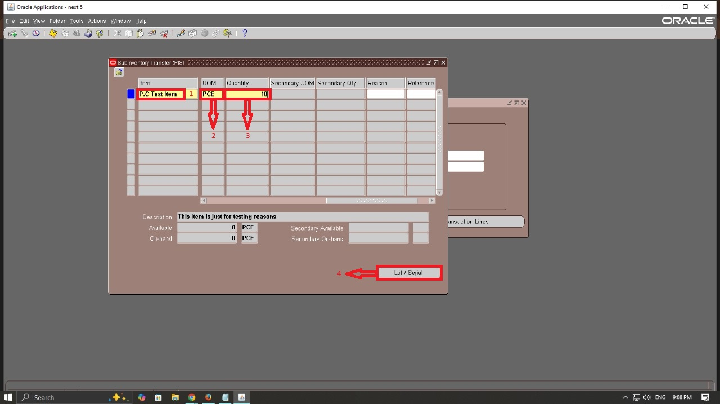

**Creating Inter-Oranization Transfer**

Step 1: Inventory > Transactions > Inter-Organization Transfer.

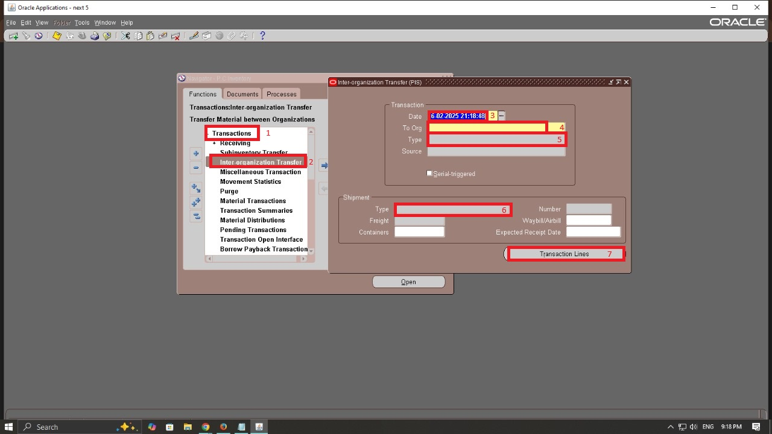

Step 2: Enter Transfer Information

1. In the Transaction window:

• Enter the Transaction Date. **(16-2-2025)**

• Select the Destination Organization. **(6th of October)**

• Choose the type. **Intransit Shipment**

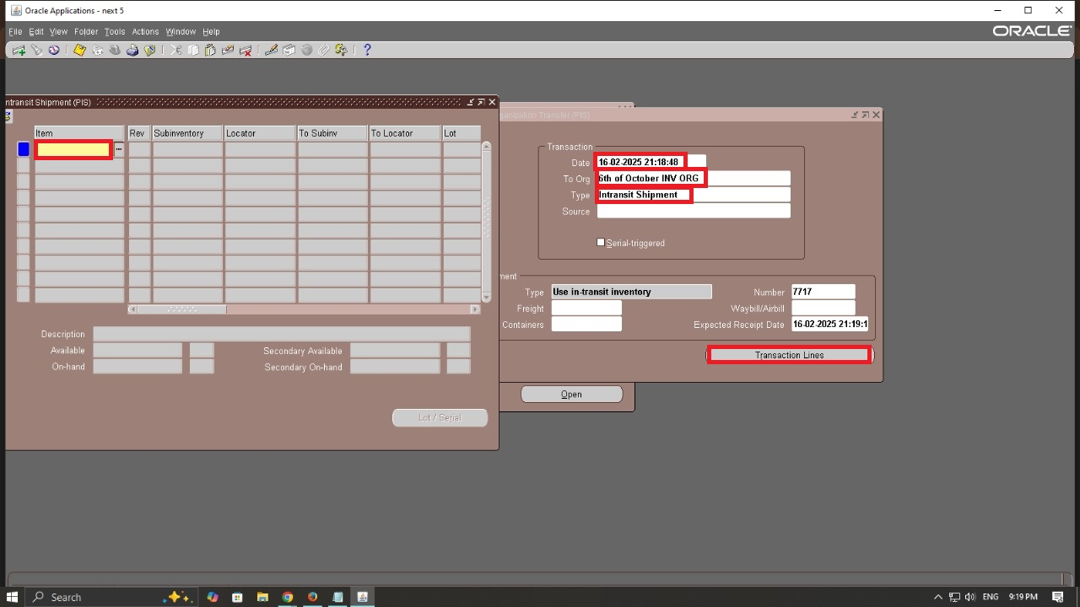

Step 3: Enter Transfer Details

• UOM (Unit of Measure): **PCE**

• Quantity: Enter the number of units to transfer. **(10)**

• Click Lot/Serial

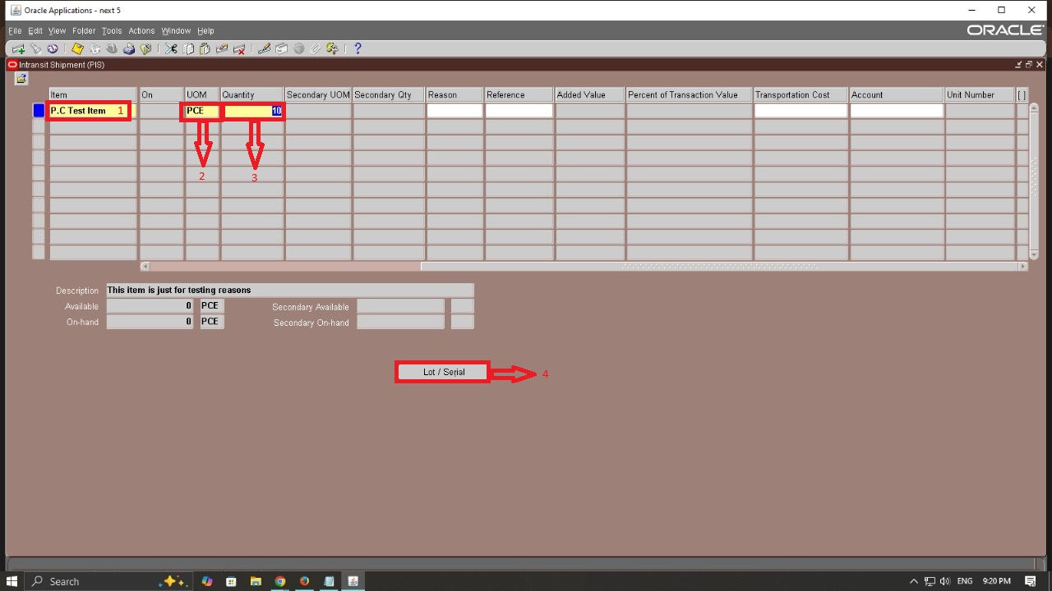

Step 1: from Inventory

Responsibility > Counting > Physical Inventory.

Click on New and enter the following details:

Description: A short description of the physical inventory.

Approval Required:

Never:

No approval is required for count entry or adjustments.

Always:

Approval is required for all inventory count entries and adjustments.

If Out of Tolerance:

Approval is required only if adjustments exceed predefined tolerance limits.

Dynamic Entry Allowed: Select if you allow entry of new items during the count.

count sub-inventories: all: Counts are performed for all sub inventories in the organization.

Specific: Counts are performed for selected sub inventories only.

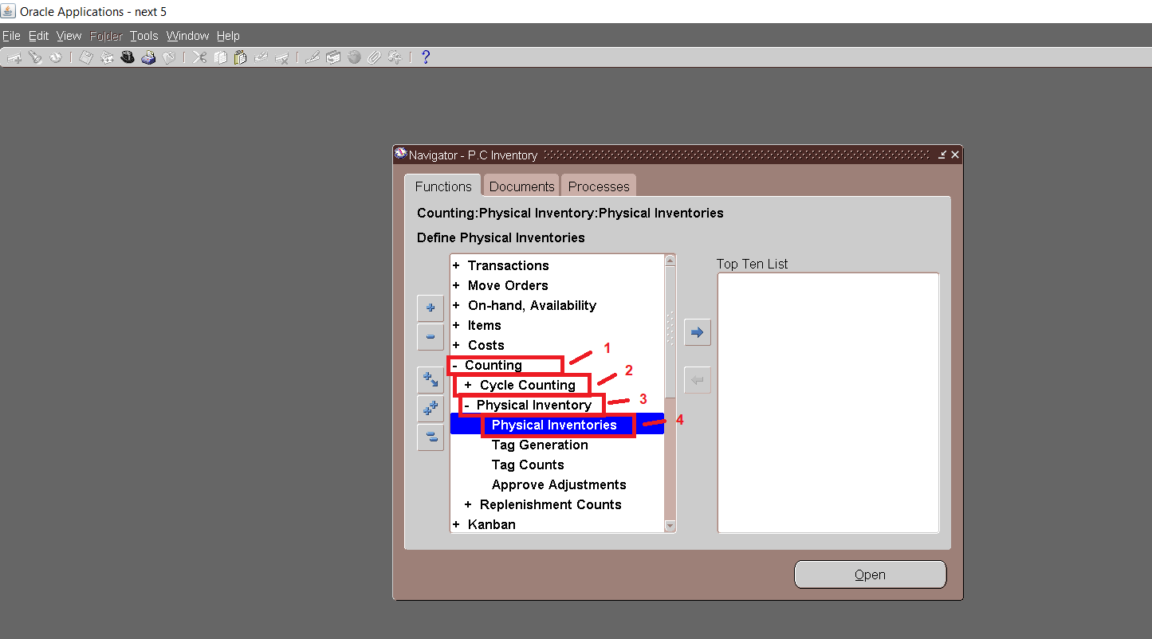

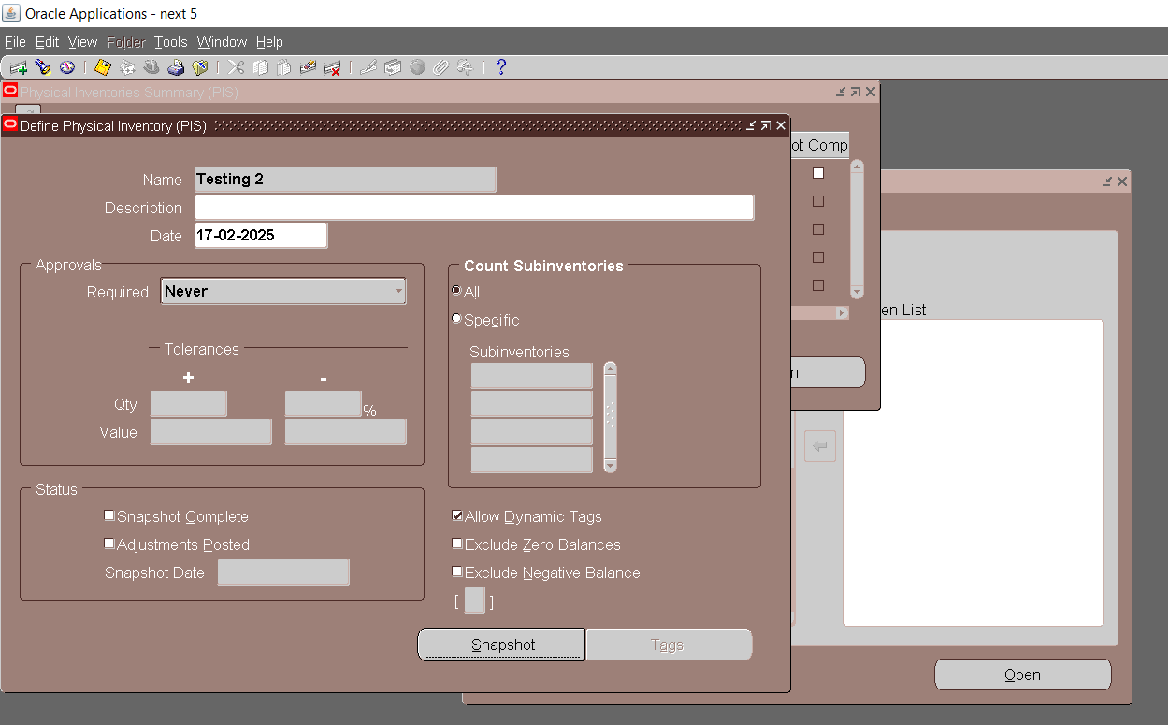

Step 2: **Tag Generation** Counting > Physical Inventory > Tag Generation.

Type of Tags:

Blank Tags: Manually enter item details later.

Default Tags: Automatically include the item, sub-inventory, locator, lot, and serial details.

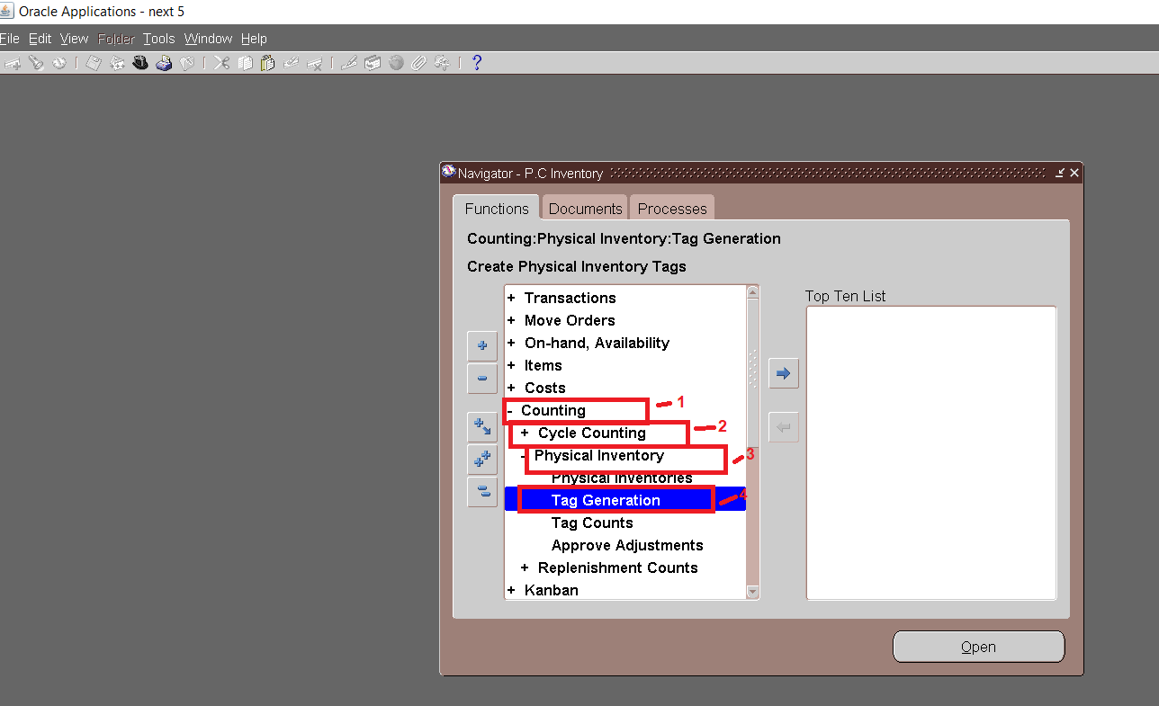

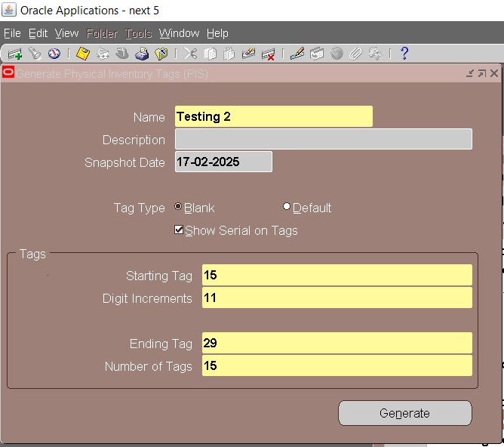

Step 3: **Tag Counts** Counting > Physical Inventory > Tag Counts.

Query the generated tags.

Enter the actual counted quantities.

Save the counts.

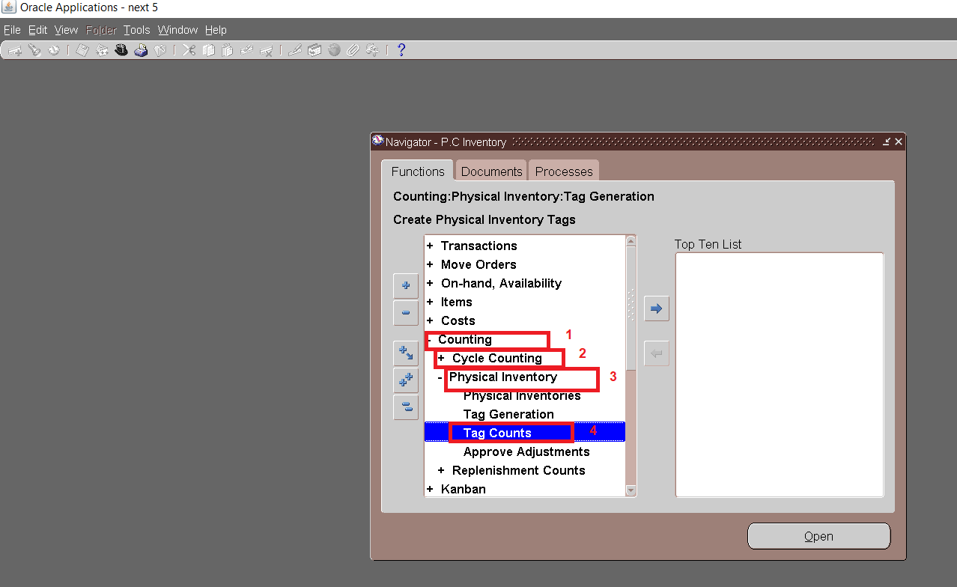

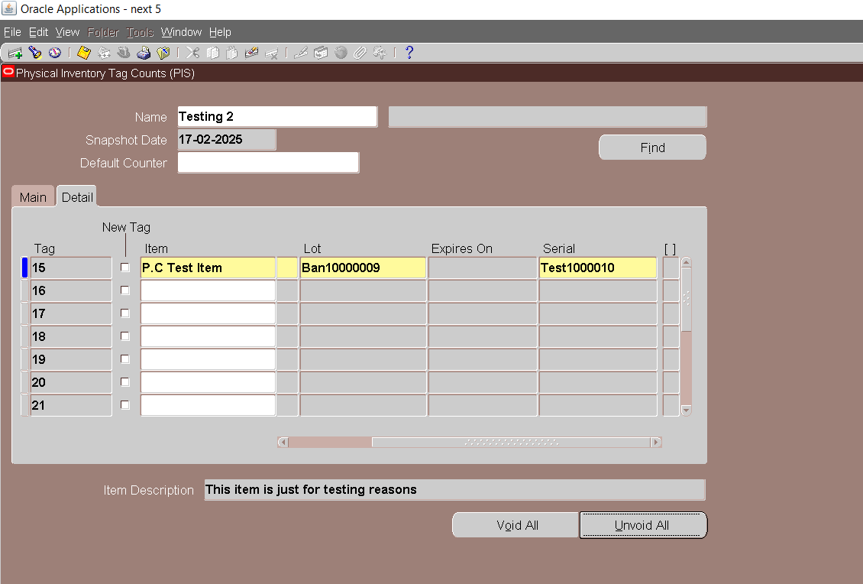

Step 4: **Approve Physical Counts**

Counting > Physical Inventory > Approve Counts.

Select the physical inventory and approve or reject the counts.

